PERSONALITY ASSESSMENT

I took the **16personalities** personality test and received the result **which I had to pay for.**This suggests I’m a strategic thinker who values logic, structure, and long-term planning

.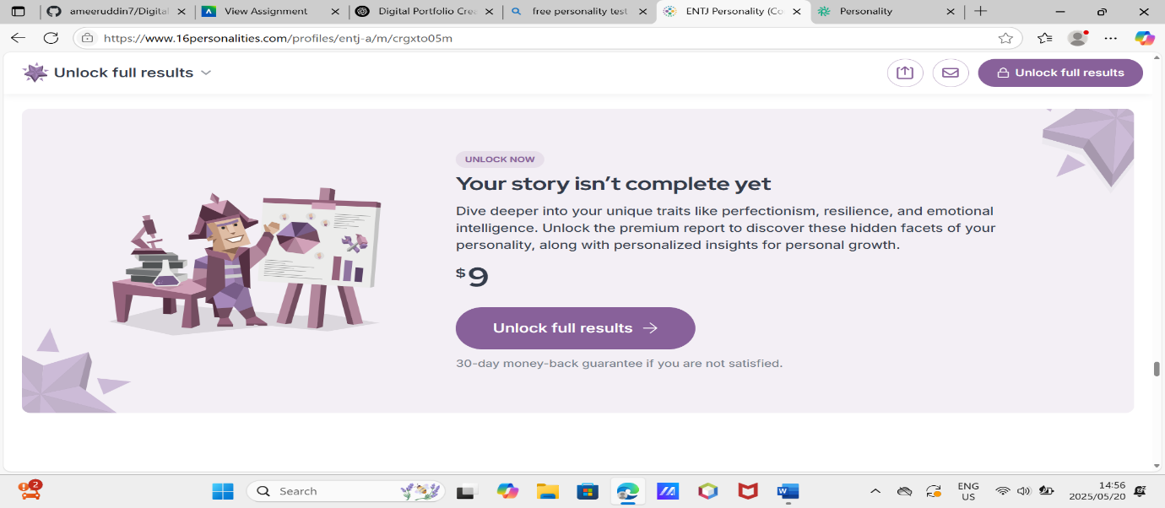

**STAR TECHNIQUE**

* **Situation:** I was curious about how my personality traits influence my work style and career compatibility.
* **Task:** I aimed to understand my behavioral tendencies in a professional context.
* **Action:** I completed the 16personalaties test and analyzed the results.
* **Result:** I learned that I thrive in environments that require independent thinking and strategy. This insight helped me understand my team role preferences and leadership style.